39.19: Heisenberg’s Uncertainty Principles tells us that:
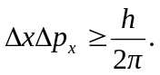 We can treat the standard deviation as a direct measure of uncertainty. 